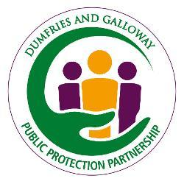
Multi Agency Self-Neglect Assessment Tool
Author: | Kim Irving in collaboration with Self Neglect Priority Steering Group
Approved by: | Julie White Chair on behalf of the Self Neglect Steering Group
Sign off Date: | August 2025
Ownership: | PPC
Review Date: | October 2025

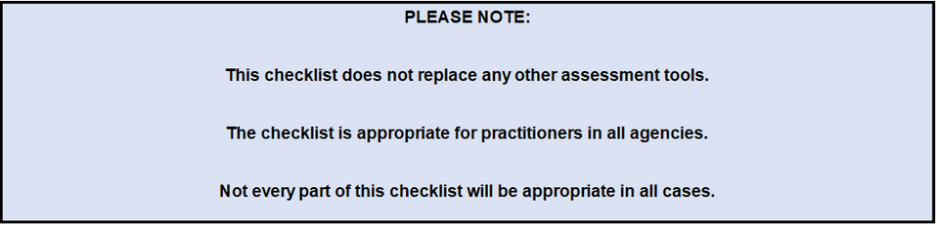
As with all tools professional judgment should be applied in relation to your expertise, knowledge, experience and ethical standards in making decisions or undertaking assessments in relation to self-neglect.

Key aspects of professional judgment include:
- Experience: Drawing on past knowledge and experiences to guide decisions.
- Critical Thinking: Analysing information and considering different perspectives before making decisions.
- Ethical Considerations: Ensuring that decisions align with ethical standards and values, especially when the decisions involve people's well-being, safety and protection.
- Expertise: Utilising specialised knowledge and relevant training in relation to self-neglect.
- Context: Understanding the specific context of a situation, as this can affect the appropriateness of different options.
- Risk Management: Assessing the potential risks and outcomes of different decisions, often under uncertainty
- Professional judgment is crucial when assessing self-neglect, where decisions can significantly impact individuals, organisations, and communities.

Guide to RAG ratings:
Rating Scale 0-3
0 Not applicable
1- Referral /support from Universal Services and or Primary Care should be considered
2 – Referral to specialist services and or social Work should be considered
3- ASP (AP1) referral to Adult Social Work Single Access Point (SAP)
Name:
Address:
Telephone Number:
Practitioner Name:
Job title:
Email Address & Telephone Number

- Health & Medication
(1)Low Risk | (2)Medium Risk | (3)High Risk | Risk level & Action Taken
Health needs generally met by universal services. Most appointments kept or re arranged as needed | Inconsistent self-management of physical health e.g. inconsistent concordance with medication evidence of dehydration/weight loss/obesity infection/diarrhoea/vomiting/or new skin conditions such as ulcers, skin sores | Poor self-management of physical health resulting in significant or life-threatening harm e.g. refusing to consent to treatment  Non concordance with prescribed medication / awaiting Level C medication package

- Personal Hygiene
(1)Low Risk | (2)Medium Risk | (3)High Risk | Risk level & Action Taken
Appears able to self-manage personal care and hygiene Personal Hygiene appears to be self-managed No evidence/elf report of skin breakdown  No identified risk to people providing support or services. | Appears unable to maintain and manage some aspects of personal care and hygiene including clothing.  e.g. wearing inappropriate clothing for the weather  and/or  Limited number of clothes available to change or allow washing which has the potential to impact on health and well being | Consistently fails to maintain personal hygiene, wearing same /inappropriate clothes/ unable / unwilling to wash them, and/or unmanaged continence causing risk of pressure ulcers, skin integrity, infection, sepsis and/or untreated oral health issues and presence of infection and /or, gryphotic toe/fingernails causing pain

- Substance Use
(1)Low Risk | (2)Medium Risk | (3)High Risk | Risk level & Action Taken
There is no objective evidence or subjective reports of substance use* at time of assessment.  May have a history of substance use but:  is concordant with prescribed medication in relation to substance use e.g. methadone, buprenorphine, disulfiram,  is engaging with prescribing service. | Evidence of current substance use such as:  appearing under the influence,  drug screen/breathalyser results (noted as part of clinical care plan).  Maybe having an impact on:  ability to undertake tasks e.g. care giving roles, sustaining employment,  self-care, health and well-being,  relationships with family and wider community.  There may be non-concordance with substance related prescribing and decreased engagement with prescribing service noted. | Substance use is markedly evident and is having a significant and pervasive impact causing a loss of control in most or all of the person’s life such as:  - the person’s self-care,  - health and well-being with the potential risk of long-lasting health damage or death.  - Relationship in the same household (particularly considering impact on any children) as well as in the wider social circle and local community,  - criminal activity leading to contact with Police and Justice services,  - Financial hardship  - Loss or neglect of property.

- Mental Health
(1)Low Risk | (2)Medium Risk | (3)High Risk | Risk level & Action Taken (if score is 2 or 3 an advice request should be made to Community Mental Health)
No mental health concerns or low concerns that are managed well by universal service engagement and symptoms have minimal impact on wellbeing or functioning. | Mental health presentation is variable, intermittent engagement with services/treatment. Mental health impacts on ability to function. | Disengagement and/or chaotic engagement with services inc non concordance with treatment/protection plan and/or Inpatient admission due to deterioration in mental health.

- Making Decisions
If you have a concern about an individual’s ability to make a decision and who you feel is at risk of significant harm - please complete the Specific Decision-Making Tool SDMT FINAL Version .docx  This tool is designed for members of professional teams working with adults where there is a query in relation to an individual’s capacity for decision making. It is designed to support such professionals in considering, and then agreeing, whether a formal assessment of capacity should be sought. | Risk Level / Action Taken  Low/Med  Med/High  High/Very High
If you have answered YES consistently to Q1-Q7, and NO to Q8, in the specific decision-making tool the adult is considered on the balance of probability, to have the capacity to make this particular decision at this time. However, consideration should still be given to Adult Support and Protection legislation and/or other supports as appropriate.
If you have answered NOT SURE or NO a request a formal capacity assessment should be made as per the referral A or B as appropriate.

- Safety
(1)Low Risk | (2)Medium Risk | (3)High Risk | Risk level & Action Taken/ Comments
Some awareness and management of home and/or online safety issues | Aware of important safety issues but may need advice from professionals or their support networks to address them. Ie online fraud, financial harm, home safety such as fire alarms , risks of hoarding explained etc | Lacks awareness and perception except for immediate danger and or unwilling or unable to identify and or manage significant risks in the home or online, such as safeguarding home and belongings, bank details

- Home Environment
(1)Low Risk | (2)Medium Risk | (3)High Risk | Risk level & Action Taken/ Comments
Able to maintain household with minimal support and has appropriate heating, fixtures and fittings, hot water and bath/ shower facilities | Support required from external agencies / own support network to ensure home is safe due to self-neglect and hoarding behaviours . Consider applying Clutter Scale | Significant risk due to self-neglect and or hoarding. Intervention from Scottish Fire & Rescue, Police and or environmental health due to levels of neglect and or hoarding  Includes risk of homelessness/eviction

- Managing Finances
(1)Low Risk | (2)Medium Risk | (3)High Risk | Risk level & Action Taken
Access to salary/pension or benefits and can manage these independently | Access to salary or benefits but some concerns regarding ability to manage without additional support | Significant concerns regarding financial status including lack of appropriate benefits debts or other issues which funds are prioritised for, and or at risk of financial exploitation / harm

- Carers/ Support
(1)Low Risk | (2)Medium Risk | (3)High Risk | Risk level & Action Taken
Supported by formal and/or informal carers, which is self-managed, and the person and carers are aware of potential risks | Supported by own networks and or external agencies, but engagement and risk assessments vary /or limited or no support; and isolation is cause for concern | Limited or no Support from informal carers is and or person refuses help or support and/or no carer support currently in place when need has been established causing significant concern

- Social Isolation / Loneliness
- Low Risk | (2)Medium Risk | (3)High | Risk level & Action Taken
Maintains own well being and welfare | Social isolation and lack of engagement/ access to community support causing some concern | Significant risk of harm identified due to loneliness & isolation/ and/ or at risk of exploitation such as sexual, financial etc

Screening Analysis / Outcomes
Area & Level of Concern (0-3) | Summary & Analysis
1. Health & Medication
2. Personal Hygiene
3. Substance Use
4.Mental Health
5. Making decisions
6. Safety
7. Home Environment
8. Managing Finances

9. Carers / Support

10. Social isolation / Loneliness

Total : - /30
Other comments
Please note if/when you have a ‘high/ ‘score of 3) for any areas and are referring to social work recommendations must be clearly outlined within the referral click here to Make an AP1 referral to social work

